LLaMA-Adapter: Fine-Tuning

Zero-init Attention. Prevalent PEFT methods might potentially disturb the pre-trained linguistic knowledge by directly inserting randomly initialized modules. This leads to unstable fine-tuning with large loss value at early training stages. LLaMA-Adapter adopts a zero-init attention with gating to mitigate this.

Unified Multi-modal Tuning. Previous PEFT methods are normally developed to address specific modalities, such as language, image, and audio. In contrast, LLaMA-Adapter can handle both language and multimodality fine-tuning with a unified manner, demonstrating superior generalization ability.

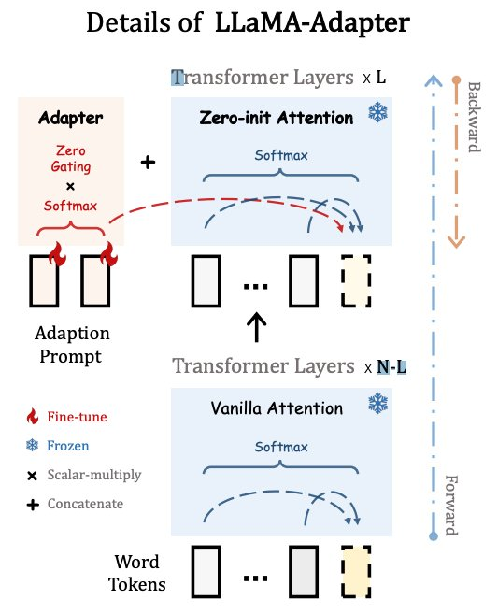

Only adapter top L layer

Prompt: K x C
Adapter M x C

After: (K+M) x C

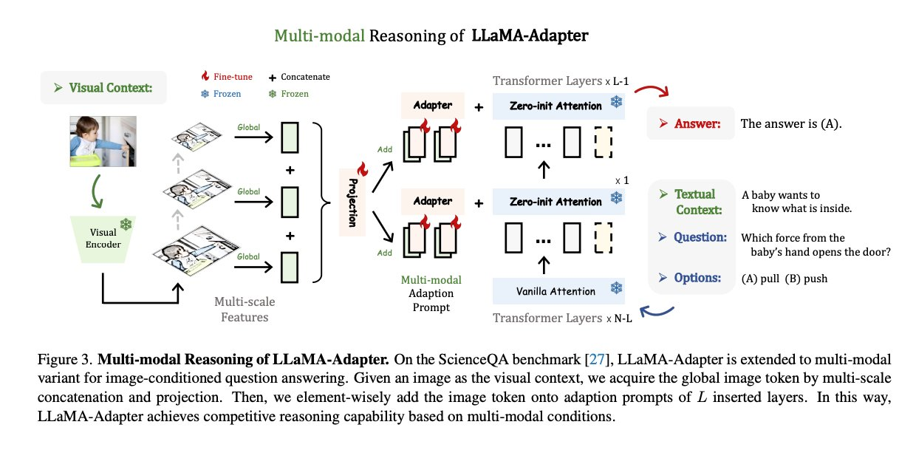
Implementation Details. We build LLaMa-Adapter based on the original LLaMa codebase2 with minor modifications. We train LLaMa-Adapter on 8 A100 GPUs for 5 epochs. The warmup epochs, batch size, learning rate, and weight decay are set to 2, 64, 9e-3, and 0.02, respectively. In general, we utilize the pre-trained LLaMA model with 7B parameters and N = 32 transformer layers as the base model. We set the prompt length K = 10 and insert prompts into the last L = 30 layers by default. Other variants of LLaMA-Adapter with different inserted layers are also released in our code. In the generation stage, we adopt top-p sampling as the default decoding method with a temperature 0.1 and a top-p = 0.75.

Ablation
Insertion Layers. We first investigate the number of transformer layers to be inserted in LLaMA-Adapter. As shown in Table 3, increasing the layer numbers introduces more parameters, but leads to a large improvement in the accuracy of ScienceQA’s validation set, e.g., +17.41% from 10 to 30, and +10.49% from 20 to 30. It indicates that more adaption prompts at different layers can provide stronger task-specific guidance to the pre-trained LLaM

Zero-initialized Attention. Our proposed attention mechanism is essential for the early-stage training stability and final generation capacity of LLaMA-Adapter. As shown in Table 4, it contributes to a significant +43.08% performance gain on the validation set. In contrast, the randomly initialized baseline only achieves 40.77% accuracy, nearly the same as ‘Random Choice’ (see Table 2’s first row). This comparison demonstrates the decisive role of zero-initialized attention in our approach. In Figure 7, we plot the loss curves with and without the zero initialization, where the ‘zero-init attention’ converges faster and reaches lower loss bounds than ‘rand-init attention’.

Robustness to Over-fitting. As the fine-tuning data of large language models is normally much smaller-scale than the pre-training data, researchers have to carefully tune a set of hyperparameters to avoid over-fitting. In Table 6, we show our LLaMA-Adapter is relatively robust to the over-fitting issue. Similar to the conclusion in [46], even if our model has over-fitted the fine-tuning data, e.g., the validation loss marginally varies from 0.136 (15 epochs) to 0.282 (60 epochs), the validation accuracy is still increasing, e.g., from 82.08% to 83.94%. This is because, LLaMA-Adapter keeps the pre-trained LLaMA 7B model frozen, and only learns lightweight adapters with a few parameters.

